Demographic consequences of changes in gear selectivity

Sarah B. M. Kraak and Coilin Minto

Fisheries advice scientists are often asked to advise on the consequences of gear changes. For example, they are asked to calculate the projected stock status and yield for a number of years in the future under two scenarios, (i) the status-quo case with the current gear, and (ii) the case that all or part of the fleet takes up an alternative gear with different selection parameters. Usually the calculations are done using the year-by-age matrix, the age-based Baranov catch equation, and the exponential equation for the changes in population numbers-at-age by cohort, both based on assumed values of fishing mortality rate-at-age (F-at-age) and natural mortality rate-at-age (M-at-age). Relative F-at-age is usually referred to as the exploitation pattern or the selection pattern. This selection pattern reflects the selectivity of the gear. Underlying the selection-at-age pattern, is the selection-at-length pattern, which is usually referred to as the selection ogive. This describes the notion that with a particular constellation of the gear, e.g. mesh size, individual fish of a small size can escape through the net, while with increasing size the probability of being retained in the net increases, until at sufficiently large size all individuals are retained in the net. The dependence on size varies with the shape of the fish and therefore by species. Fisheries scientists usually work with species-specific selection parameters describing the ogive. The species-specific parameters of course differ by gear. These parameters can be estimated from numbers at length, measured in experimental trials with the gear, by fitting a logistic curve. These will have the following form:
logit(r(l)) = a + bl
where r(l) is the probability that a fish at length l is retained in the net given that it entered the net. The curve is characterised by two selection parameters, a and b, that define the length at which the probability to be retained is 50%, L50, and the selection range, SR=L75-L25, as
L50 = -a/b, SR = ln(9)/b.
Usually, scientists proceed as follows. The selection pattern of the status-quo case is given by an analytical stock assessment, for example by taking the average of the most recent three years. For the alternative gear scenario they calculate the new selection pattern from the mean length-at-age and the logistic selection curve. The mean length-at-age may be derived from age-length keys (ALK) or from growth parameters according to a growth model, e.g. the Von Bertalanffy growth model. Thus, the scientist assumes length-at-age to be a fixed biological property of the species/population.

In this short communication, however, we wish to highlight the fact that a change in size-selective fishing actually changes the size-at-age distribution in the population, and that as a consequence, the selection-at-age will differ accordingly. Note that this is a purely demographic effect and should not be confused with any fisheries-induced genetic shifts in size-at-age that may take place on an evolutionary time scale.

In figure 1 we visualise this effect by following a hypothetical cohort. The initial length distribution is assumed to be lognormal around a mean length-at-age-1 calculated using assumed Von Bertalanffy parameters. We assume that underlying the theoretical lognormal distributions of length-at-age is a distribution of growth trajectories: a fish that belonged to a certain percentile class of size at its first age will continue to belong to the same percentile class at all future ages; in other words, slow-growing fish remain slow-growing fish, and fast-growing fish remain fast-growing fish. The figure 1a visualises the growth trajectories based on the Von Bertalanffy parameters. The distribution curves in figure 1b follow the fate of the cohort. At each age the black curve represents the initial length distribution, the blue curve represents the length distribution of the survivors after natural mortality at an assumed rate, the red curve represents the length distribution of the survivors after additional fishing mortality at a rate specified by length according to a logistic function with assumed selection parameters. Note that natural mortality acts independently of length and that the black and blue curves have the same central location, but that the fishing mortality is length-dependent and that therefore the red curve has its central location shifted to smaller size. Finally, the green curve represents the survivors after natural and fishing mortality and after growth to their respective length at the next age; this curve is the same as the black curve at the next age. Note that because growth slows down at older ages (as seen in the growth trajectories and also reflected as a smaller difference between the red and green curves) but length-dependent selection is still taking place (reflected as the downward shift in centrality between the blue and the red curves), as a result mean length decreases at older ages (such that older surviving fish are on average smaller than younger ones). Overall, mean length-at-age becomes progressively smaller than would have been inferred from the original Von Bertalanffy growth curves. Conversely, this implies bias when trying to infer Von Bertalanffy parameters from samples of a fished population. Because the resulting location of the length-at-age distribution will differ between gears with different selection parameters, as a consequence there will also be differences in the population’s weight-at-age as well as maturity-at-age when having been fished with different gears (affecting yield and SSB as well). Of course this model can be refined, e.g. in by using smaller time steps: quarter or month. We also arbitrarily assumed natural mortality to take place before fishing mortality.
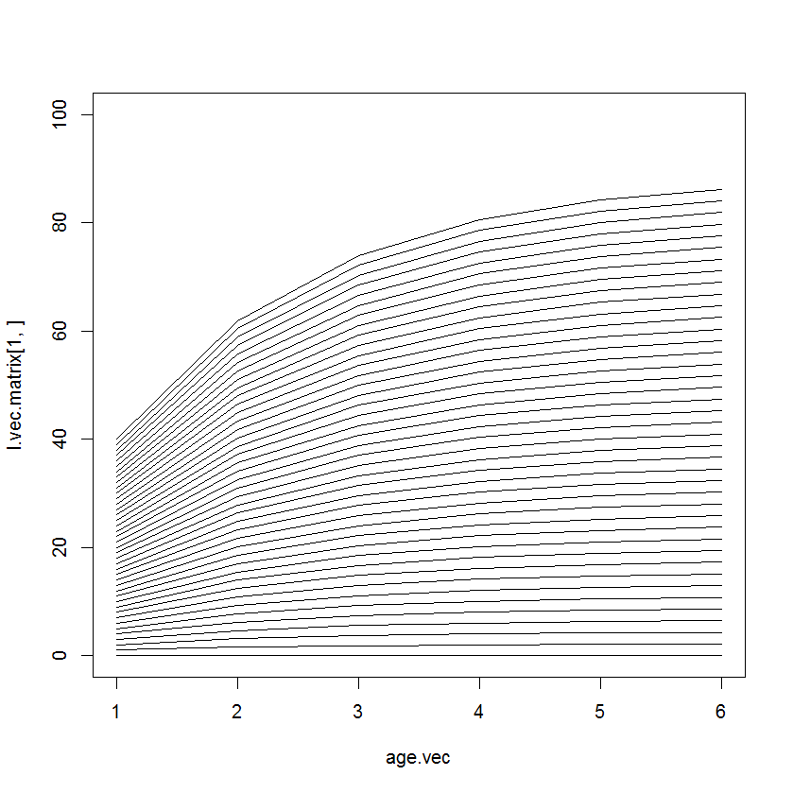
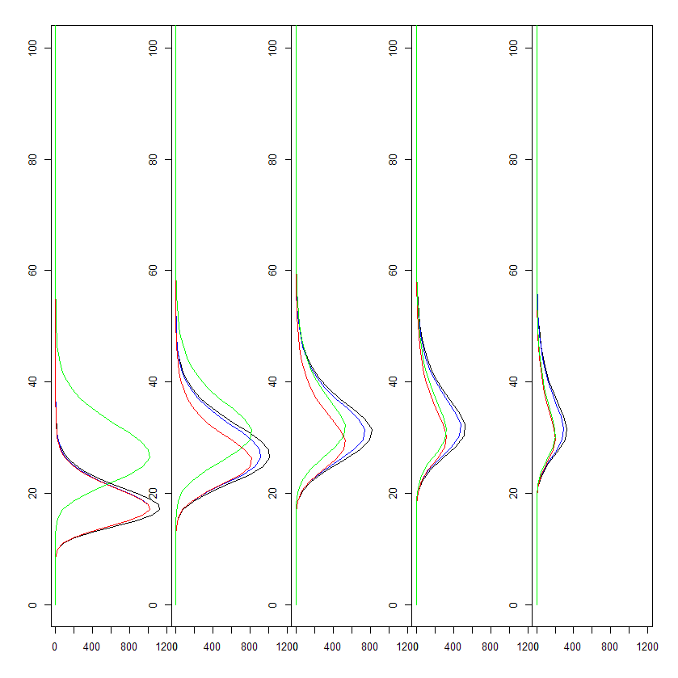

Below we compare the projection of a fish population done incorrectly, i.e. without taking this effect into account, with a projection done correctly according to our reasoning above. We will show that the difference can be quite substantial. [still to come – we should plan to stay close to Norman’s haddock data].

